**SHOUHARDA GHOSH**

**17EC30044**

**COMPUTATION OF ELECTROSTATIC PARAMTERS OF SQUARE PLATES BY NUMERICAL TECHNIQUES**

INTRODUCTION

The following document is a result of the Matlab codes and simulations that have been used to numerically analyse the capacitance and field for a single plate at unity voltage and a parallel plate capacitor at ±0.5V.

The numerical method that has been used is Legendre Gauss Quadrature method which is known to have a very high degree of accuracy of calculating definite integrals.

In all cases we have assumed the plate to have dimensions 1m×1m.

For double plate capacitor, we have assumed distance between plates to be 0.5m.

ACCURACY OF LEGENDRE GAUSS METHOD

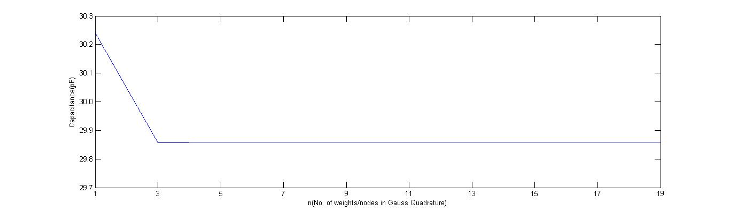

Capacitance (Double Plate) vs Order of quadrature method

As can be seen from the graph, we have used odd order of quadrature to allow for symmetry between the nodes. The value of capacitance gets constant immediately after n=3.

Hence we may easily resort to n=3, for all such programs pertaining to the capacitance, so as to minimize the space complexity of the MATLAB program.

CAPACITANCEvs ORDER OF PLATES

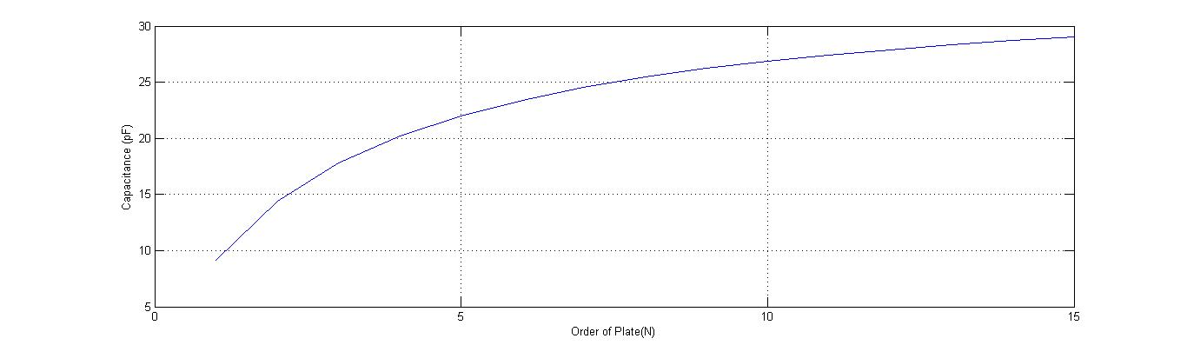

Capacitance (Double Plate) vs Order of Plates

The order of the plate(N) refers to the N*N matrix which the plate has been decomposed into. An intuitive thinking leads us to the fact that the higher the order of the plate, the greater is the numerical accuracy of the capacitance calculated. However we need to take care of the fact that since the efficiency of the algorithm used is not high , we need to take an optimum value of N ,say 10.

CAPACITANCE vs DISTANCE BETWEEN PLATES

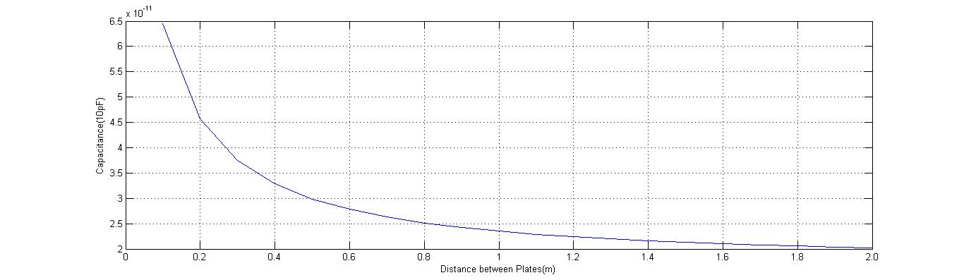

Capacitance (Double plate) vs Distance between plates

From theory we know that $C=\frac{ϵA}{d}$.

From the graph we can easily visualize that the Capacitance follows the same inverse relation with distance as expected theoretically.

The program is accurate enough to calculate upto the correct order of capacitance. However we do observe some difference in the magnitude as computed from program and theory.

This crops up because the theoretical formula assumes the charge distribution on the charge plate to be uniform, whereas we have some deviations in the edges of the charge plate as can be seen from charge distribution figure given below.

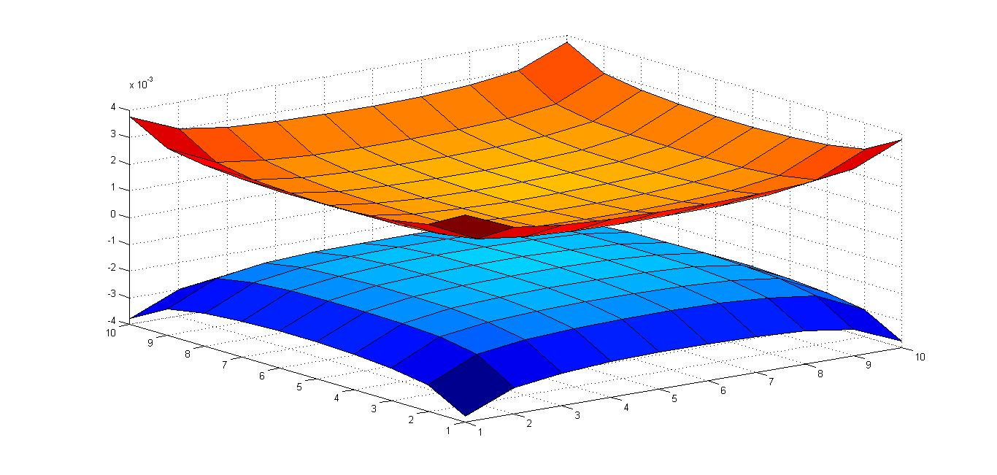

FRINGING OF ELECTRIC FIELDS

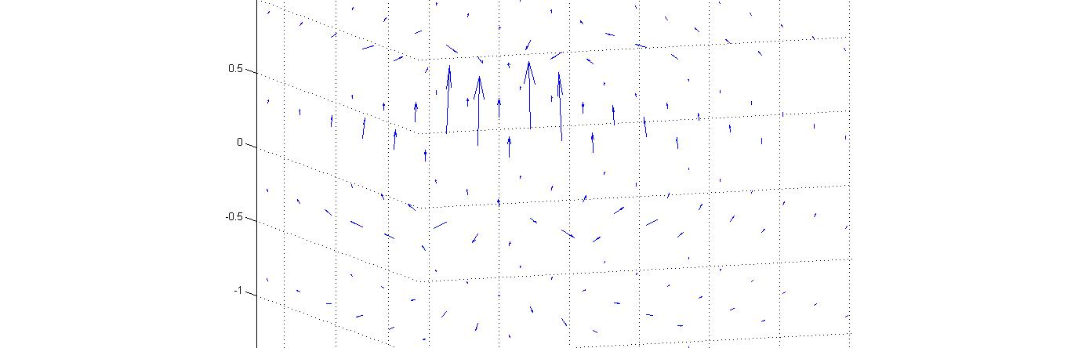

In an ideal case we expect the electric field to be confined only within the plates of the capacitor and no field outside it.

However, in reality, field lines of comparatively lower magnitude exist outside the plate and we observe a fringing field.

As can be seen from the figure, the 4 large vectors represent the field in the capacitor, whereas the smaller vectors are showing the curved flow of field outside the capacitor.

SINGLE PLATE CHARGE DISTRIBUTION

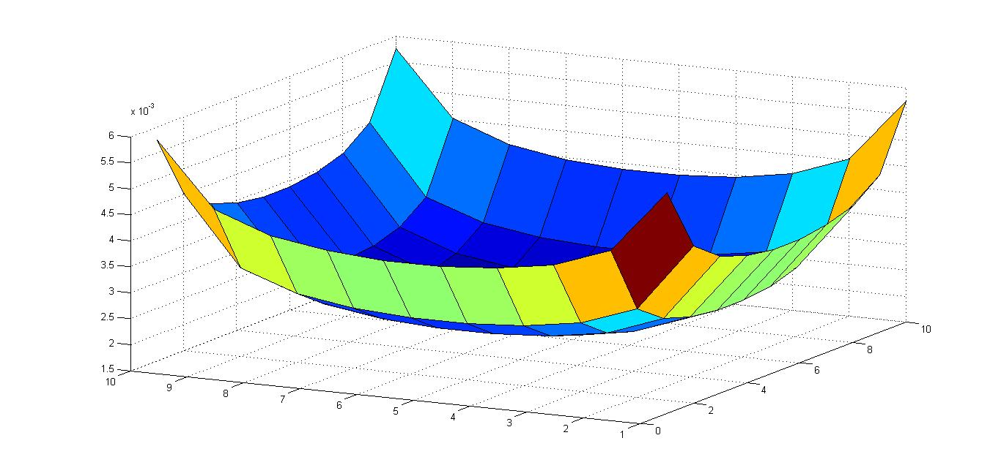

SINGLE PLATE FIELD DISTRIBUTION

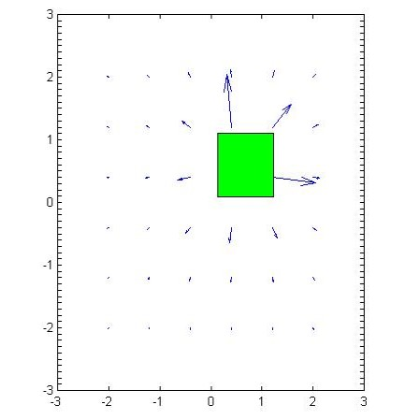

SINGLE PLATE CAPACITANCE vs ORDER OF PLATE

